Last Rev. 5/6/2024

Alexandria Colhour

Cat Color Personality Quiz

Final Project SDEV140 2024

Cat Color Quiz User Manual

|  |
| --- |
| Program Overview |

### Description

This personality quiz asks the user 9 questions, in which they rank themselves on a scale from a trait to its opposite. Each color has been placed somewhere on the scale for each particular question, and whichever color the user matches the most with will be their result!

### Question Formatting Example

|  |  |
| --- | --- |
| Question | With one being (a) and seven being (b), where would you rank yourself? |
| Button 1 | Extremely (a) |
| Button 2 | Very (a) |
| Button 3 | Moderately (a) |
| Button 4 | Sometimes (a), Sometimes (b) |
| Button 5 | Moderately (b) |
| Button 6 | Very (b) |
| Button 7 | Extremely (b) |

### Color Result Options

|  |  |
| --- | --- |
|  |  |
|  | Orange |
|  | White |
|  | Black |
|  | Gray |
|  | Bicolor |
|  | Tricolor |
|  | Tabby |

|  |
| --- |
| Program Flow |

|  |  |
| --- | --- |
|  |  |
|  | Question 1 : Tolerance |
|  | Question 2 : Aloof |
|  | Question 3 : Stubborn |
|  | Question 4 : Calm |
|  | Question 5 : Shy |
|  | Question 6 : Friendly |
|  | Question 7 : Trainable |
|  | Question 8 : Bold |
|  | Question 9 : Active |
|  | Result Popout Window |

### *Disclaimer * Don’t look forward in the manual if you don’t want result/color spoilers

|  |
| --- |
| Color Key |

|  |  |  |  |
| --- | --- | --- | --- |
| Q | Color: Orange | Button: |  |
|  | Intolerant / Tolerant | 1 |  |
|  | Nosy / Aloof | 1 |  |
|  | Docile / Stubborn | 2 |  |
|  | Hyper / Calm | 7 |  |
|  | Outgoing / Shy | 5 |  |
|  | Unfriendly / Friendly | 7 |  |
|  | Untrainable / Trainable | 7 |  |
|  | Undaring / Bold | 6 |  |
|  | Lazy / Active | 4 |  |

|  |  |  |  |
| --- | --- | --- | --- |
| Q | Color: White | Button: |  |
| 1 | Intolerant / Tolerant | 5 |  |
| 2 | Nosy / Aloof | 2 |  |
| 3 | Docile / Stubborn | 5 |  |
| 4 | Hyper / Calm | 3 |  |
| 5 | Outgoing / Shy | 2 |  |
| 6 | Unfriendly / Friendly | 4 |  |
| 7 | Untrainable / Trainable | 3 |  |
| 8 | Undaring / Bold | 4 |  |
| 9 | Lazy / Active | 3 |  |

|  |  |  |  |
| --- | --- | --- | --- |
| Q | Color: Black | Button: |  |
| 1 | Intolerant / Tolerant | 4 |  |
| 2 | Nosy / Aloof | 6 |  |
| 3 | Docile / Stubborn | 1 |  |
| 4 | Hyper / Calm | 2 |  |
| 5 | Outgoing / Shy | 1 |  |
| 6 | Unfriendly / Friendly | 3 |  |
| 7 | Untrainable / Trainable | 2 |  |
| 8 | Undaring / Bold | 1 |  |
| 9 | Lazy / Active | 1 |  |

|  |  |  |  |
| --- | --- | --- | --- |
| Q | Color: Gray | Button: |  |
| 1 | Intolerant / Tolerant | 7 |  |
| 2 | Nosy / Aloof | 7 |  |
| 3 | Docile / Stubborn | 4 |  |
| 4 | Hyper / Calm | 6 |  |
| 5 | Outgoing / Shy | 7 |  |
| 6 | Unfriendly / Friendly | 1 |  |
| 7 | Untrainable / Trainable | 1 |  |
| 8 | Undaring / Bold | 5 |  |
| 9 | Lazy / Active | 2 |  |

|  |  |  |  |
| --- | --- | --- | --- |
| Q | Color: Bicolor | Button: |  |
| 1 | Intolerant / Tolerant | 3 |  |
| 2 | Nosy / Aloof | 5 |  |
| 3 | Docile / Stubborn | 6 |  |
| 4 | Hyper / Calm | 5 |  |
| 5 | Outgoing / Shy | 6 |  |
| 6 | Unfriendly / Friendly | 5 |  |
| 7 | Untrainable / Trainable | 5 |  |
| 8 | Undaring / Bold | 2 |  |
| 9 | Lazy / Active | 5 |  |

|  |  |  |  |
| --- | --- | --- | --- |
| Q | Color: Tricolor | Button: |  |
| 1 | Intolerant / Tolerant | 6 |  |
| 2 | Nosy / Aloof | 4 |  |
| 3 | Docile / Stubborn | 7 |  |
| 4 | Hyper / Calm | 1 |  |
| 5 | Outgoing / Shy | 3 |  |
| 6 | Unfriendly / Friendly | 2 |  |
| 7 | Untrainable / Trainable | 4 |  |
| 8 | Undaring / Bold | 3 |  |
| 9 | Lazy / Active | 6 |  |

|  |  |  |  |
| --- | --- | --- | --- |
| Q | Color: Tabby | Button: |  |
| 1 | Intolerant / Tolerant | 2 |  |
| 2 | Nosy / Aloof | 3 |  |
| 3 | Docile / Stubborn | 3 |  |
| 4 | Hyper / Calm | 4 |  |
| 5 | Outgoing / Shy | 4 |  |
| 6 | Unfriendly / Friendly | 6 |  |
| 7 | Untrainable / Trainable | 6 |  |
| 8 | Undaring / Bold | 7 |  |
| 9 | Lazy / Active | 7 |  |

|  |
| --- |
| Backing Science |

|  |  |  |  |  |  |  |  |
| --- | --- | --- | --- | --- | --- | --- | --- |
| Tolerance | 1 | 5 | 4 | 7 | 3 | 6 | 2 |
| Aloof | 1 | 2 | 6 | 7 | 5 | 4 | 3 |
| Stubborn | 2 | 5 | 1 | 4 | 6 | 7 | 3 |
| Calm | 7 | 3 | 2 | 6 | 5 | 1 | 4 |
| Shy | 5 | 2 | 1 | 7 | 6 | 3 | 4 |
| Friendly | 7 | 4 | 3 | 1 | 5 | 2 | 6 |
| **Trainable** | 7 | 3 | 2 | 1 | 5 | 4 | 6 |
| Bold | 6 | 4 | 1 | 5 | 2 | 3 | 7 |
| Active | 4 | 3 | 1 | 2 | 5 | 6 | 7 |
|  | Orange | White | Black | Gray | Bicolor | Tricolor | Tabby |

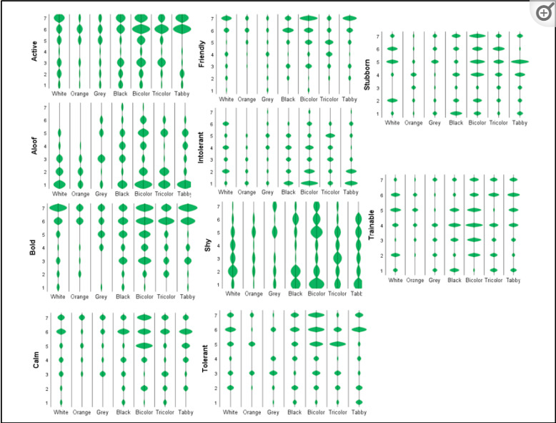

*González-Ramírez MT, Landero-Hernández R. Cat Coat Color, Personality Traits and the Cat-Owner Relationship Scale: A Study with Cat Owners in Mexico. Animals (Basel). 2022 Apr 15;12(8):1030. doi: 10.3390/ani12081030. PMID: 35454276; PMCID: PMC9024431.*